**Web Designing Assignment**

**Term-1**

**Module (HTML) – 1**

**Q:1: Are the HTML tags and elements the Same things ?**

**Ans:**  **Tags:-** are those Which comes in between angular - brackates.

:- Tags are come with starting and closing tag.

:- **Elements:-** Elements start tag - some content - end tag

**Q.2: What are tags and attributes in HTML?**

**Ans: Tags:-** Tags those Which comes in between angular-brackets.

:- Attributes:- They provides some Additional Information Which Change the behavior of Element. Come in start Tag.

**Q:3: What are Void Elements in HTML? With example?**

**Ans:** A void element is an element Whose content model never allows it to have contents under any circumstances.

**Example:-** br, img, input, command,

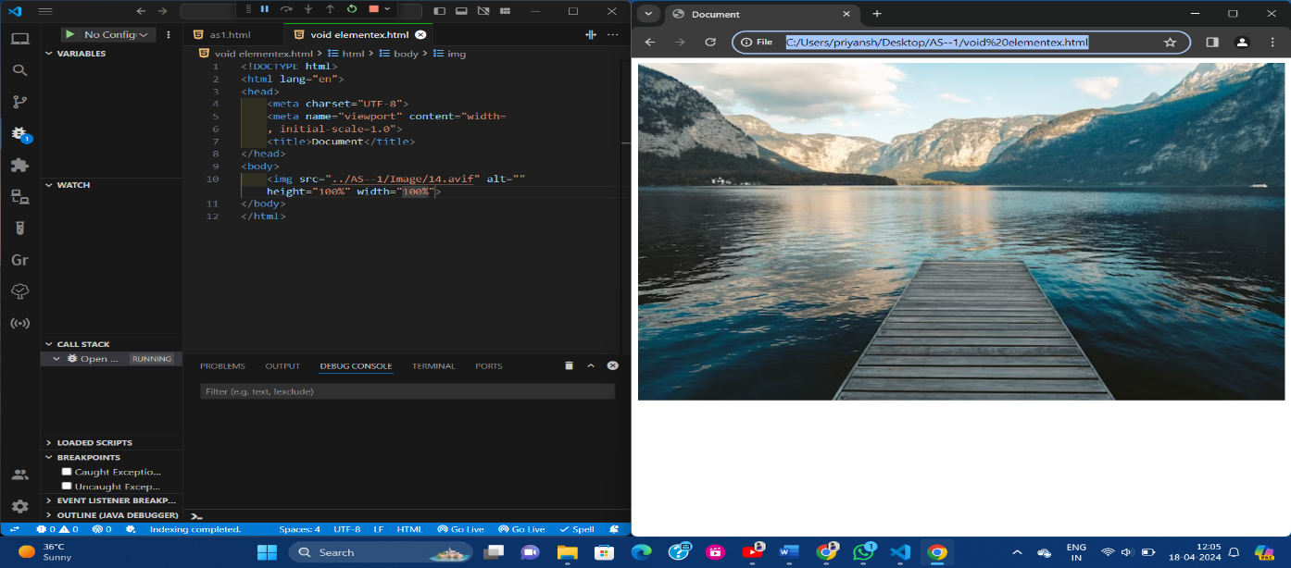**Img tag example :-**

**Q:4: What are the HTML Entities? With example?**

**Ans:** HTML entities is used to display invisible characters and reserved character that Would otherwise be interpreted as HTML code.

**:-** it is piece of text, or string, that beings with an ampersand (&) and ends with a Semicolon (;).

**Example:-**

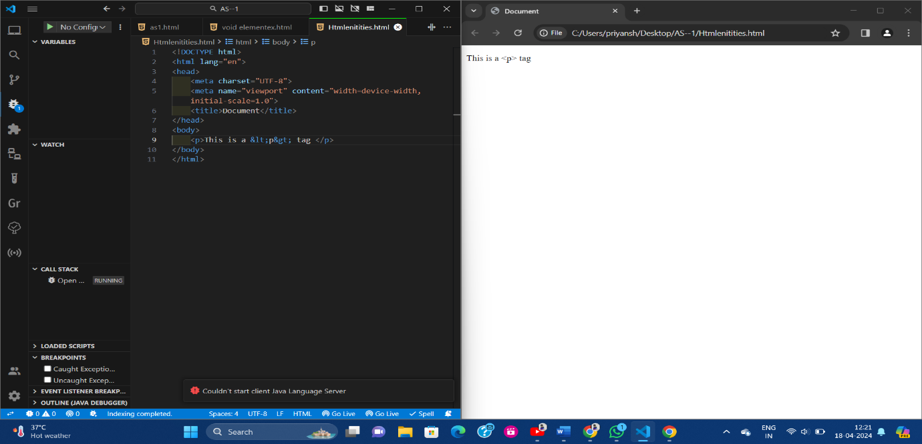

**Q:5: What are different Types of list in HTML? With example?**

**Ans:- Three types of List**

**1.Ordered list ( ol ):-** An ordered list displays item in a numbered format.

**2.Unordered list (ul):-** An unordered list displays items with bullet points.

**3.Description list (dl):-** A description list pairs terms with their descriptions.

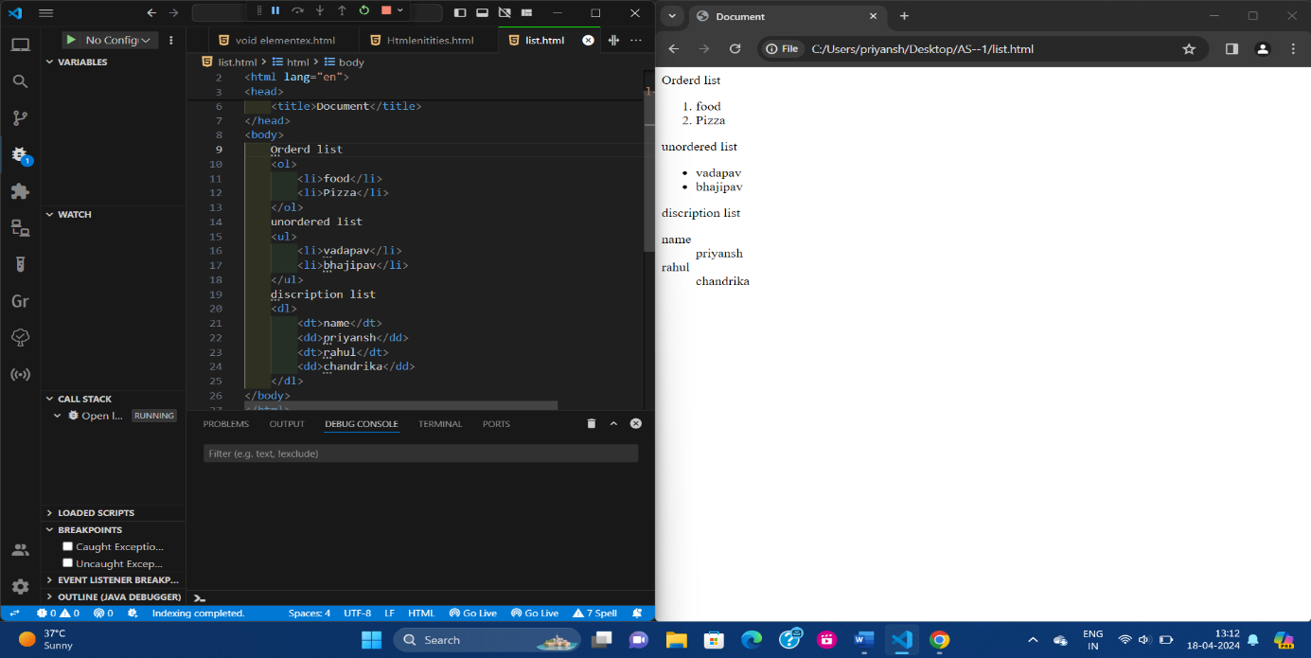**Example :-** All list example in one code .

**Q:6: What is the ‘Class’ attribute in HTML? With Example?**

**Ans:** The class attributes specify one or more class names for an element.

:- The class attributes is mostly used to point to a class in a style sheet.

**Example:-** class attribute ex

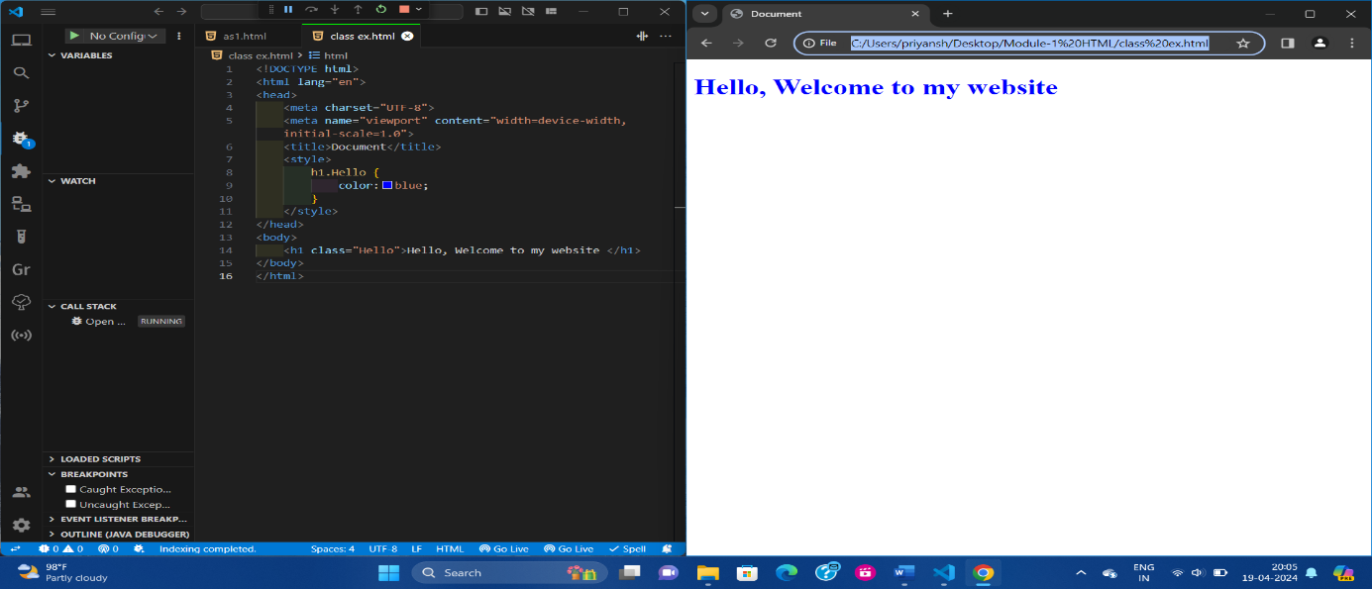

**Q:7: What is the difference between the ‘id’ attribute and the ‘class’ attribute of HTML elements? With example?**

**Ans: ‘ID’:-** The id selectors is used id attribute of an element for an HTML element the id name starts with the symbol “#” follow by unique name.

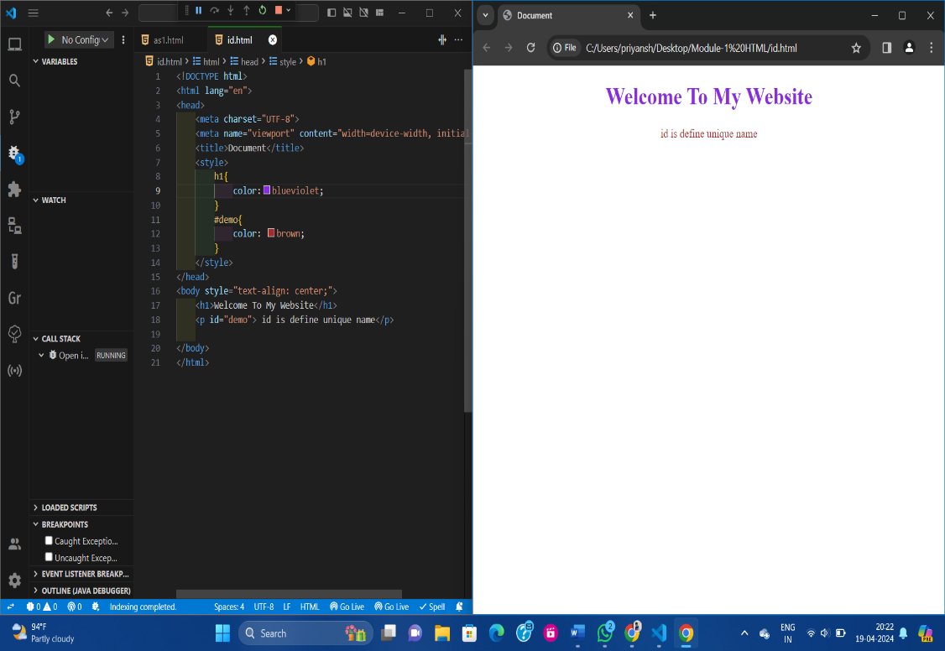**ID example:-**

**Class:-** The class selector is used to select an element with a specific class attribute . The class selector start with a period (.) follow by class name.

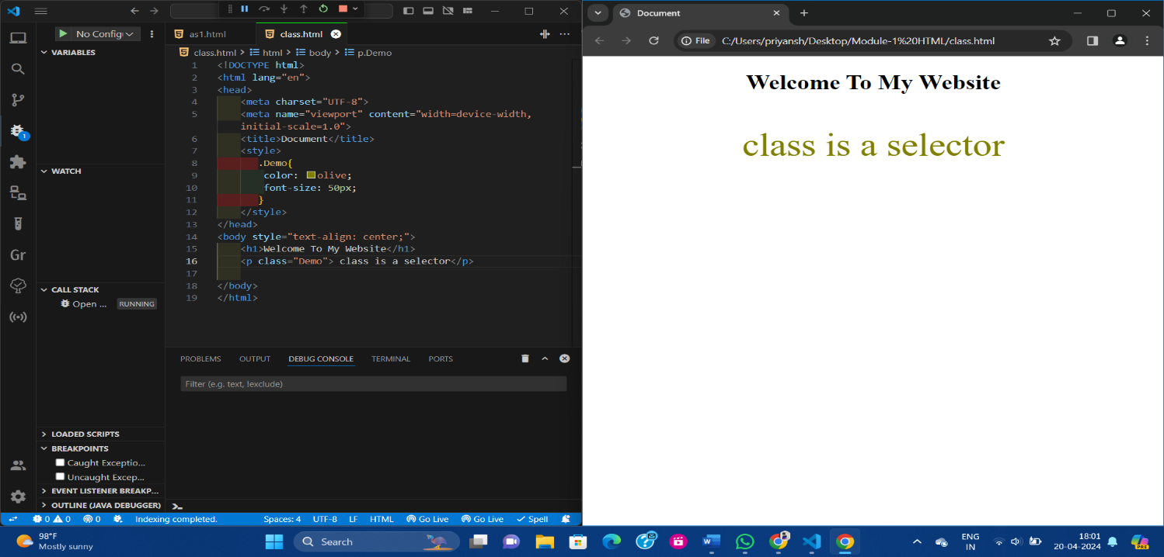**Class example:-**

**Q:8: What are the various formatting tags in HTML?**

**Ans: HTML Text formatting :-**

1. **Bold text:-** < B > & < Strong >
2. **Underlined text:-** < u >
3. **Delete:-** < del >
4. **Italic :-** < I >
5. **Horizontal rule:-** < hr >

**Q:9: How is cellpadding different from Cell Spacing? With Example?**

**Ans: Cell Padding:-** It is defined the space present between a table cell’s border and the content present in it.

**:- Cell Spacing:-** It is defined the space present between individuals adjacent cells.

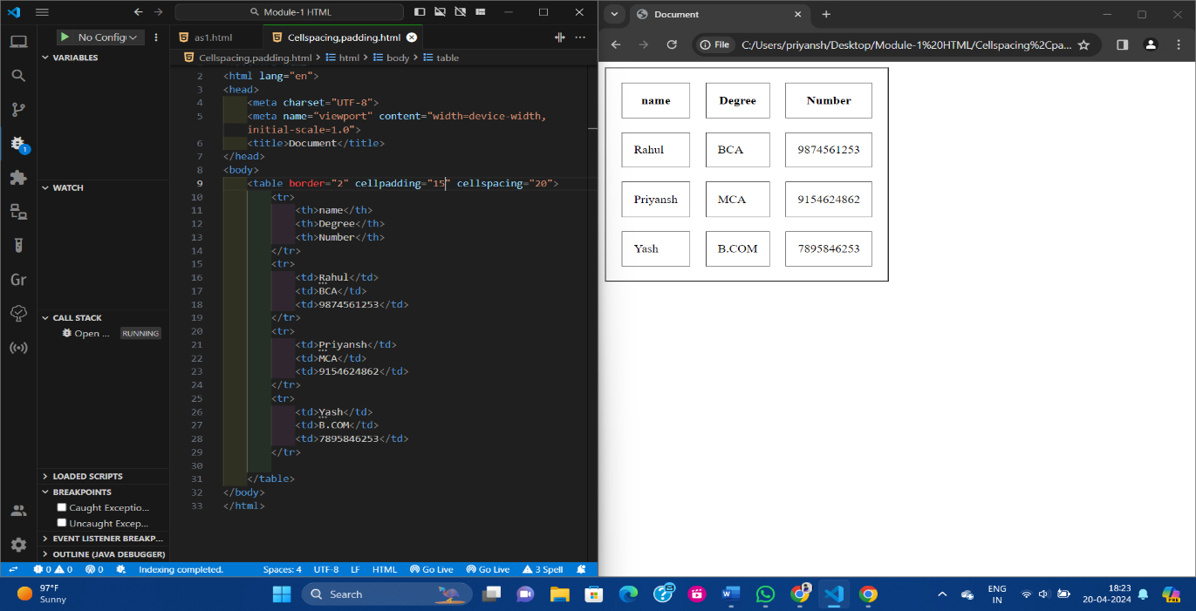**:- Example:-**

**Q:10:- How can we club two or more rows or columns into a single row or column in an HTML table? With Example?**

**Ans:-**  We use the colspan and rowspan attributes, to merge cells in HTML The rowspan attribute is for number of rows a cell should merge.

:- Where the colspan attribute is for the number of columns a cell should merge. The attribute should be placed inside the “ ” tag.

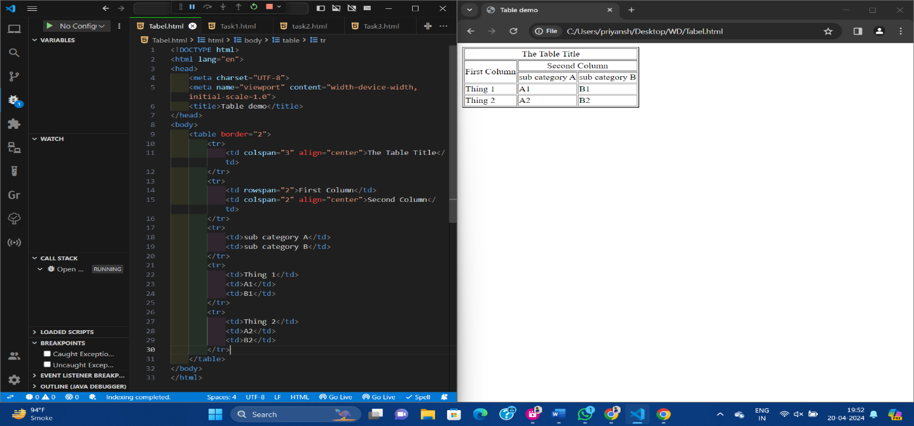**Example:-**

**Q:11: What is the difference between a block-level element and an inline element?**

**Ans:- Block-level:-** A block-level always start on a new line, and the browser automatically add some space before and after the element.

:- A block-level element always takes up the full width available.

**:- Inline element:-** A inline element does not start on a new line an inline element only takes up as much width as necessary.

:- an inline element cannot contain a block-level element.

**Q:12: How to create a Hyper link in HTML? With Example?**

**Ans:** Hyperlink in an HTML page use the ‘a’ and ‘/a’ tags which are the tags used to define the links. The ‘a’ tag indicates where is the hyperlink starts and the ‘/a’ tag indicates where it ends.

:- Whatever you text gets add inside the tags will work as a hyperlink add the URL for the link in the ‘a href = “ … ” ’

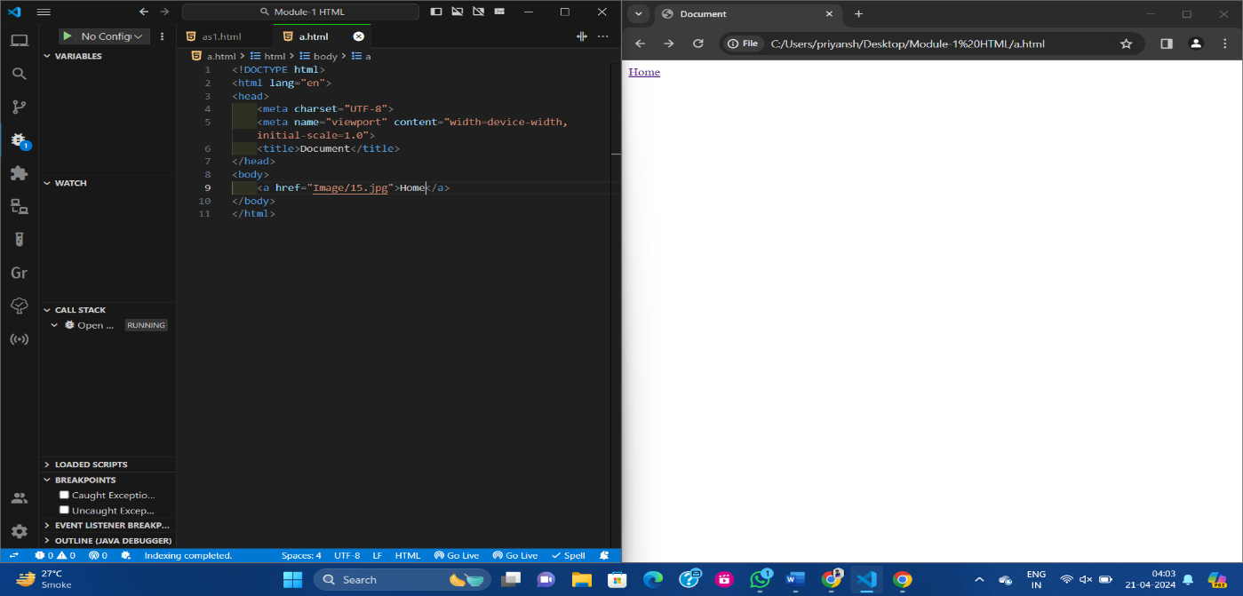**Example:-**

**Q:13: What is the use of an iframe tag? Explain with example?**

**Ans:** An inline iframe is a HTML element that loads another HTML page within the document. It essentially puts another web page within the parent page. They are commonly used for advertisement embedded video , web analytics.

**Example:-**

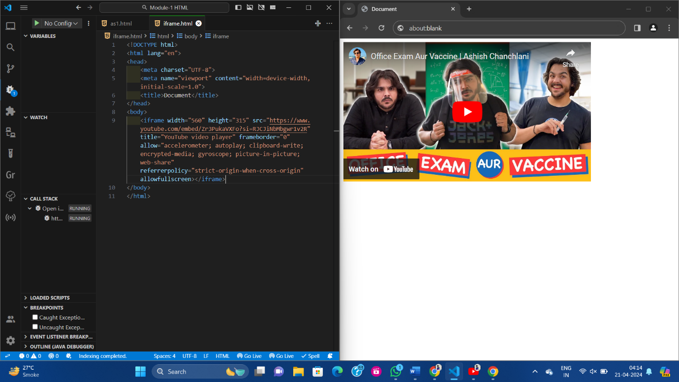

**Q:14: What is the use of a span tag? Explain with Example?**

**Ans:-** The span tag is a paired tag means it has both open ( < ) and closing ( > ) tags, and it is mandatory to close the tag.

:- The span tag is used for the grouping of inline elements & this tag does not make any visual change by itself.

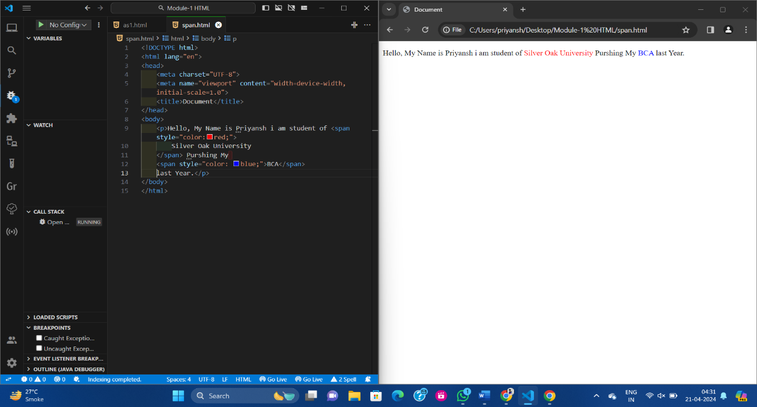**Example:-**

**Q:15: How to Insert a picture in to a background image of a web page? With Example?**

**Ans:-** Method is insert background image steps

**Step:1:-** First we will define the HTML code.

**Step:2:-** Now we will edit the body tag to use the local file image. Jpg as the background image.

**Step:3:-** First we will define the HTML code.

**Step:4:-** Now we will add CSS.

**Q:16: How are active links different from normal links?**

**Ans:- Normal link:-** it is a just a line of code that contains a pointer to another resource.

**:- Active link:-** An active link is that line of code in action, operating that other resources.

**Q:17: What are the different tags to separate sections of text?**

**Ans:- < br > :-** It is used to separate the line of text. It breaks the current line and shifts the flow of the text to a new line.

**:- < p > :-** This tag is used to write a paragraph of text. In HTML.

**:- < Img > :-** This tag is used to Add the any image in HTML.

**Q:18: What is SVG?**

**Ans:-** SVG stand for Scalable Vector Graphics. Its is used for Vector basedgraphics design XML format.

:- SVG support by all major browsers.

**Q:19: What is difference between HTML and XHTML?**

**Ans:-**

|  |  |
| --- | --- |
| **HTML** | **XHTML** |
| HTML stand for Hyper text Markup language. | XHTML stand for Extesible Hypertext markup language. |
| HTML doesn’t support name spaces. | XHTML support name space only. |
| HTML will continue to be supported by web browser | XHTML support by web browser is limited and replace by HTML 5 |
| It was released in 1993 | It was released in 2000 |
| HTML file can save with extensions .html. | An XHTML file can save with extensions .xhtml, x.ht, x.ml. |

**Q:20: Where are logical and physical tags in HTML?**

**Ans:-** HTML the formatting tags are divided into two categories.

1. **Logical Tags:-** These tags are used to add some logical or semantic value to the text.

:- **Example:-** < br >, < del >, < em > This is the logical tag example.

1. **Physical Tags:-** These tags are used to provide the visual appearance to the text.

:- **Example:-** < b >, < I >, <U> This is the Physical tag example